AFFECTIVE COMPUTING OF SPEECH EMOTION RECOGNITION USING DEEP LEARNING

V. Vidhya Sree, Kamalanaban , V. Jeevitha, N. Monika Prasad ,M. Monisha
Assistant professor, UG Scholar
Department of computer science and engineering
Vel tech high tech Dr. Rangarajan Dr. Sakunthala engineering college
vidhyasree.v@velhightech.com

Abstract
Human-Computer Interaction (HCI) requires the difficult task of emotion recognition from speech signals. Many approaches have been employed in the literature on speech emotion recognition (SER). The paper proposes a deep learning-based speech emotion recognition system (SER) that can detect emotions in real - time and generate context-aware notifications. It also covers the database used for emotion extraction. This paper provides an overview of Deep Learning techniques. How does this work? The RAVDESS dataset is being examined in this research. The extraction of three primary characteristics, namely Mel Frequency Cepstral Coefficient (MFCC), Mel Spectrogram, and Chroma, allows for the prediction of emotions through different states such as tone, pitch, expression, behaviour, etc. To sum up, SER is an innovative technology that is revolutionizing the way humans and machines interact by enabling systems to develop emotional awareness. Even though there are still issues with accuracy and generalization, advancements in research methods and technology are opening new opportunities for advanced applications in various fields.

keywords— Affective computing, speech emotion recognition, deep learning, CNN, LSTM,

I.INTRODUCTION
Computers should have the ability to recognize various emotional states of users to enhance human-machine interaction, as emotion is a crucial component of human communication. Speech Emotion Recognition (SER) is a technology that helps machines recognize and interpret human emotions by using speech signals. SER systems can identify emotions such as happiness, sadness, anger, and surprise by examining the vocal characteristics of pitch, tone, rhythm, energy, or frequency. It is a capability that can improve human-computer interactions, making them more intuitive and responsive to the user's emotional state. Speech Emotion Recognition (SER) is a field that deals with the identification and processing of speech signals in artificial intelligence and human-computer interaction. It is an interdisciplinary field. The meaning and interpretation of spoken words are influenced by emotions, making emotional connections more significant. Traditional. Although it concentrates on the content of speech, SER seeks to go beyond words by examining vocal characteristics such as tone, pitch, rhythm, and intensity to identify emotional states like happiness or anger, sadness, surprise, or fear. Machines can communicate with emotion in a natural and intuitive way, making them more responsive to human emotions. This is possible due to the ability to understand speech. Human-machine dialogue systems require SER to become more natural and effective. Why? It concentrates on identifying emotions in speech, aiding in interactions within intelligent environments, virtual assistants, and call centres. ".
Virtual assistants (e.g., Alexa, Siri). The importance of SER cannot be overstated, as it can be applied to different areas such as smart environments, customer support, and call centres. Additionally, knowing the emotional state of an individual mental health patient can aid in selecting appropriate care plans. SER systems must be both robust and precise as technology advances with voice. Despite this, it is challenging to detect emotions with high precision due to the complexity of human emotions, differences in speech patterns among individuals, and external factors such as background noise or cultural differences. The progress in this area can be attributed to the recent machine learning advancements, including deep learning, which have made it possible to perform more accurate and timely assessments of emotions. With advancements in the field, introducing SER systems to everyday use is expected to transform human-computer interaction into an emotionally engaged and responsive experience. [A]. The incorporation of SER into practical applications has fostered stronger connections between humans and computers. Although SER has been implemented in many significant languages, other languages can be predicted with reasonable precision using the same model. However, this is not applicable to language traits. Each language requires specific database. This contrasts with linguistic features that necessitate a language-specific model, which can be problematic for lesser-known or regional languages lacking labelled emotion data. The development of Speech Emotion Recognition (SER) has become more important with the increasing popularity of voice-based technologies, such as virtual assistants (e.g. Siri, Alexa), call centres, and healthcare applications that consider emotions. Machines can respond to users in a more human-like way by comprehending emotions and speech, which helps them interact more smoothly. This is particularly useful in the context of social interaction. The recognition of frustration or satisfaction in a customer's voice by systems can enhance user experience and satisfaction. Mental health specialists can use SER to track emotional changes and identify early symptoms of psychological issues such as stress, anxiety, or depression. This research is crucial for improving mental health.
Speech Emotion Recognition is a combination of several domains:
1.Speech Processing: Enables the extraction of specific characteristics from audio signals, such as pitch, energy, and spectral features, that are utilized for detecting emotions.
2. Artificial Intelligence: Classes emotions using machine learning and deep learning algorithms such as SVMs, CNNs & RNNS.
3. Human-Computer Interaction (HCI): Enhances the interaction between humans and machines by enabling systems to detect and respond to emotional stimuli with precision.
4. Psychology and Behavioural Science: Emotions are expressed in speech, and the categories of emotion are used in recognition algorithms.[A].
5. Healthcare and Therapy: Aids in the identification and tracking of mental health issues by examining speech patterns in patients.
6. Customer Service and Marketing: Improves customer experience by detecting emotional disseising or frustrated voice calls and enabling targeted marketing using that information.
II.LITERATURE SURVEY
A survey of the literature on Speech Emotion Recognition (SER) reveals significant progress and research achievements in the field. In 2019, J. Zhao et al. employed software such as TensorFlow, Keras, Librosa, and Python to analyse SER datasets like RAVDESS, in addition to the open-source platforms IEMOCAP and CREACAD. They also conducted experiments on real-world data sets from Japan. They found that traditional machine learning approaches such as SVM, Random Forest and KNN were mainly used in older systems, where features like pitch, energy and MFCCs were manually engineered (a technique known as Mach 2D). A new approach to emotion classification, based on the use of CNNs and RNN-based algorithms for sequential data processing, was suggested by the authors.[2].
In 2024, Vlad Strategic, Cosmin Stratelich and Adriana Stan developed TBDM-Net, meanwhile, an innovative bidirectional dense network specifically designed for SER. They aimed to address the shortcomings of CNN-based systems that were already in place but did not consider gender-related factors in emotion recognition accuracy. With the addition of gender data and gender information, TBDM-Net demonstrated an improvement in emotion detection performance by using bidirectional dilated convolutions. In 2024, Junfeng Zhang and Hong Xing conducted another study that utilized the Double Multi-Head Attention (DMHA) model for SER challenges. The technique combined raw waveform features that had been extracted from self-trained models. By capturing intricate relationships between speech features, the study went beyond feature extraction and aimed to improve generalization.
Furthermore, the implementation of data augmentation techniques enhanced their proposed system's durability. The Deep EMO system, which utilized a GPU-based framework and relied on ResNet18 and the RAVDESS datasets, was proposed by Zhao et al. in 2024. While traditional SERs relied on handcrafted features or basic machine learning, Deep EMO utilized transfer learning and deep CNN techniques, offering improved accuracy in detecting emotions [4]. In this survey, we can see a shift from machine learning to deep learning in SER, with an emphasis on the use of new architectures that address various problems, as well as advanced feature extraction techniques and gender issues that focus on exploiting existing weaknesses. A survey of the literature on Speech Emotion Recognition (SER) highlights several advances and research contributions.
In 2024, Junfeng Zhang and Lining Xing presented the Double Multi-Head Attention (DMHA) model that employs a combination of raw waveform features extracted from pre-trained self-supervised models. This system does not use CNN-based feature extraction, instead using attention mechanisms to process raw audio data directly and capture complex relationships between features for improved generalization. This data augmentation further improved the strength of the system[5].
Zhao et al. proposed the Deep EMO model in 2024, which utilized the ResNet18 architecture and the RAVDESS dataset with GPU-based computation. High accuracy is achieved by transfer learning neural networks that use Mel spectrogram features. In addition, this model used augmentation techniques along with mixed convolutional and recurrent architectures to ensure consistent results across different environments. Singh et al. released a potent SER model in the same year, which integrates CNN and LSTM architectures. Their approach was aimed at solving the issues of previous methods, which were problematic with noisy datasets and had limited generalizability. Through the use of CNNs for feature extraction and LSTMs, the proposed model was made more robust by improving its classification under various conditions.
III.EXISTING SYSTEM
In the context of Speech Emotion Recognition (SER) using Deep Learning, existing systems use more sophisticated neural network architectures to extract features automatically and classify emotion from speech.
While traditional methods are superior in capturing more intricate and non-linear patterns in the audio signal, these systems also present their own set of challenges. The. Speech Emotion Recognition (SER) systems are sophisticated tools that can detect and interpret the emotional signals expressed in speech. The raw speech data is typically pre-processed by these systems, which can then include tasks like removing noise, normalizing, and breaking down the speech into smaller units called frames. Through these segments, the system can direct attention to specific emotional moments in the speech. Having extracted relevant features, the system then uses machine learning or deep learning models to classify the emotional content of the speech.
Earlier approaches to machine learning utilized mainly conventional methods like Support Vector Machines (SVM), Random Forests, or K-Nearest Neighbours (KNN), but newer models employ deep learning models such as Recurrent Neural Networks and Long Short-Term Memory (LSTM) networks, along with Transformer-based architectures for processing the temporal and contextual features of speech. The limitations of SER systems are numerous, regardless of their usefulness. The expression of emotions varies across individuals, with different cultures, languages, ages, and genders contributing to the difficulty of generalizing. Additionally, it is often difficult to accurately describe emotions through speech, and external stimuli such as background noise or distorted audio can make the analysis more complex.
These systems enable human-computer interaction to produce more natural and emotionally sensitive virtual assistants or chatbots that can recognize and respond to the user's emotional state. In automotive or safety-related scenarios, SER systems can identify the emotional state of drivers, such as stress or tiredness, and take necessary steps to ensure their safety. These systems, while not Despite obstacles, advancements are taking place, creating fresh opportunities for emotionally intelligent technology in diverse fields.

Deep Learning Architectures
A) Convolutional Neural Networks (CNNs):
The use of CNNs in image and audio recognition tasks is due to their capacity to learn spatial hierarchies of features automatically. In SER, high-level features are learned and extracted from spectrogram representations of speech using the use of CNNs. By using convolutional filters, the network learns local temporal patterns and emotional cues to improve the quality of the spectrogram.
B)Recurrent Neural Networks (RNNs)
Long Short-Term Memory (LSTM) networks, which are commonly used to store speech, make RNNs a viable option for processing sequential data. Unlike CNNs, which model local features in terms of temporal dependencies, RNNs can model dynamic speech signals over time. Emotions are often expressed in the way speech evolves over time, making it a crucial aspect of SER. LSTMs, which are part of RNN, can store long-term dependencies, making them useful in the analysis of complex speech patterns. The integration of RNNs with CNNs has been shown to improve the spatial and temporal accuracy of emotion recognition.
C)Transformers:
Recently, speech emotion recognition has been using transformers that were initially created to perform NLP-based tasks. Unlike RNNs, transformers model the relationships between parts of the speech signal using self-attention mechanisms.
DRAWBACKS IN EXISTING SYSTEM
To achieve optimal performance, deep learning models, particularly end-to–end systems, must utilize significant quantities of labelled emotional speech data. The effectiveness of modeling is often based on the speaker, which results in poor generalization across different types of testing. However, they find it difficult to generalize across different speakers (speaker-independent) due to differences in accent, pitch and speaking style, among other vocal characteristics. Although there are some noise reduction methods available, they are not very efficient and may be less reliable in real-world scenarios.

IV.ARCHITECTURE DIAGRAM
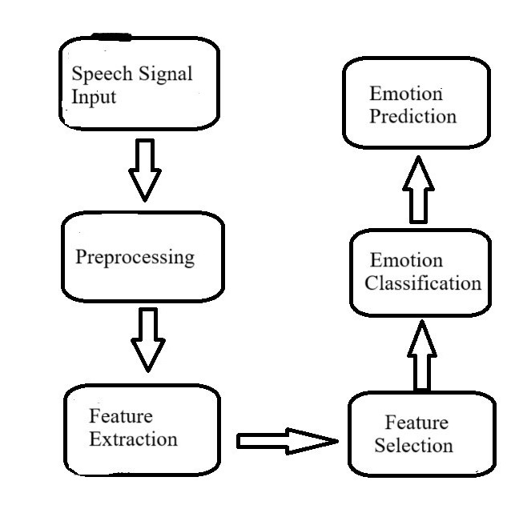

IV. PROPOSED SYSTEM
The work's methodology is outlined in the following section. A system's order of actions is explained in this section. A flowchart illustrates the operation of this speech-emotion recognition system.
Emotion recognition using speech involves the use of feature extraction. The aim is to generate representative images of the audio signal that capture the attributes linked to various emotional states. The following are some familiar characteristics and how they were acquired:.
I. Mel-Frequency Cepstral Coefficients (MFCCs) : Record the spectral features of speech, which are closely linked to the human auditory system.
1. Pre-emphasis: Amplify high frequencies.
What is the value of y[n] = x[r] - alpha for every number less than or equal to 0 and 1?
2. Chroma Features: Describe the pitch of speech. Transform the signal into a CQT type.
Spectral Feature:
A spectrum's center of mass, or spectral centroid. The equation "SC = fracsum_k=1 n" is equivalent to the square root of N. Measures the extent of the spectrum using spectral Bandwidth.' The inequality "SB" is equal to the square root of each binary code i.e, not more than one number in its interval equation.
Prosodic Feature:
Voice (F0): Denotes the pitch, which can be extracted using autocorrelation or algorithms such as Praat.
Energy: Measures loudness.
Energy = \sum_{n=1}{N} x[n]2.
II. High-Level Features.
Amplify sound frequencies in the vocal cavity. Calculated using various methods such as, Harmonics-to-Noise Ratio (HNR)Measures voice quality and breathiness. Temporal and Statistical Features. Measure statistics in lieu of feature-based ones:
Mean, mean standard deviation, skewness, and kurtosis are the identified conditions. Delta Derivatives and First-Delta Features. Feature Extraction Tools.
Python Libraries:
The term libera pertains to MFCCs, their chroma, and spectral characteristics.' The Praet is designed to provide guidance on pitch and formants. Detailed by Audio Analysis programs for audio analysis.
III.DATA COLLECTION
Data collection is a critical step in creating a Speech Emotion Recognition (SER) system.
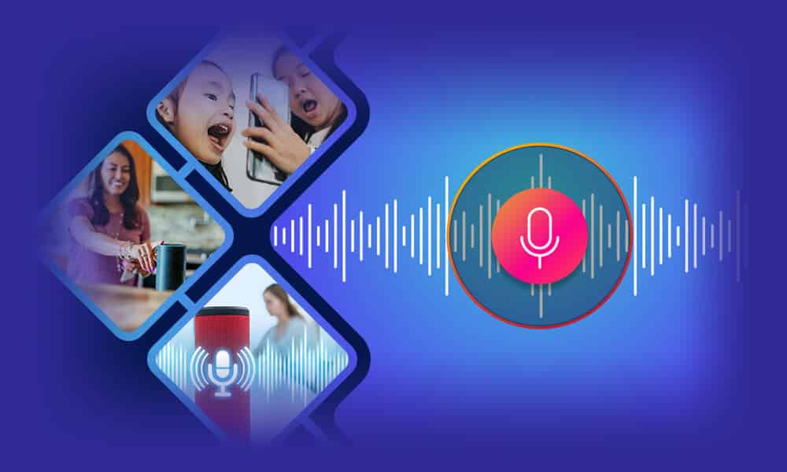
Fig .1.1 DATA COLLECTION
1.Define Your Goals and Emotions.
Determine the emotions that you wish to identify (e.g, content, annoyance, neutrality), fear, intrigue, etc.). For more effective model training, make sure your dataset covers all target emotions.
2. Pre-recorded Datasets.
Use open datasets, such as:. What is RAVDESS? (Ryerson Audio-Visual Database of Emotional Speech and Song). IEMOCAP captures motion pictures with active emotional distortion. What is it? The CREMA-D (Crowd-sourced Emotional Multimodal Actors Dataset) Emo-DB, which is the Berlin Database of Emotional Speech.

3. Data Annotation.
Label emotions accurately. Listen to speech and organize it by human annotation.? To use multiple annotators and ensure consistency and bias. Firstly, mark out the emotion and use either an annotation tool or software, then check the Audio Quality by hand. Use audio recordings with diverse noise intensities to train robust models:
High-quality recordings: Studio settings. Real-world recordings: Background noise, distortions. Normalize audio formats and levels (e.g. 16-bit WAV, 44.1 kHz). What are these options?
Data Preprocessing: Separate extended sound recordings into smaller segments with only one sentence.
Reduction of Noise: Use filters such as Audacity, or libraries in Python (such as Librosa). Normalize the volume levels and durations.
V.CHALLENGES
Training deep learning models with diverse sets of emotional speech samples requires access to large, annotated datasets. However, it is difficult to obtain high-quality datasets that represent different emotions across diverse demographics and languages.
Variability in Emotions: Egos can be expressed differently even within the same person. A universal system of emotion recognition is difficult due to factors such as speech rate, accent and differences in expression from person to person (for example, hearing-to-speech). The use of speech recognition systems in a noisy environment can have varying effects on the effectiveness of emotion recognition models. Many deep learning models are tested and trained on a particular dataset, but their cross-scale evaluation may not be effective for other datasets. Despite efforts to improve cross-corpus performance, it remains an issue in practical applications.

VI. RESULT AND DISCUSSION

After uploading the speech audio, it will preprocess and display the emotion audio along with a bar chart and audio pitch.
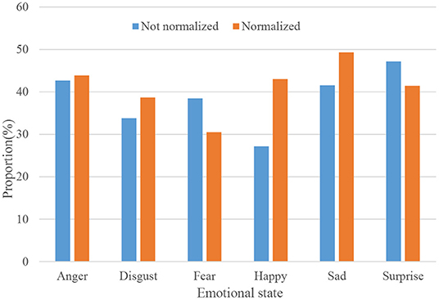
Fig.1.2 BAR CHART

Fig.1.3 AUDIO
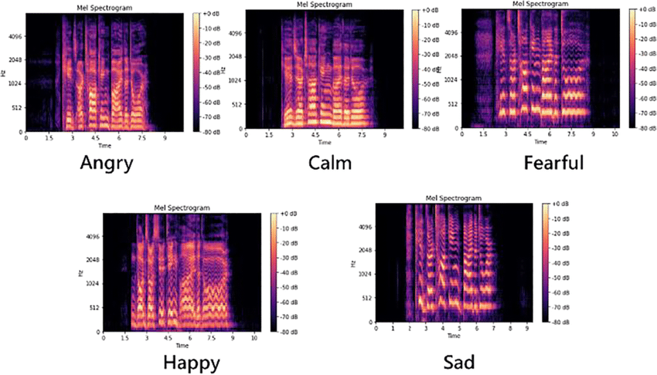
Fig.1.4 SPECTOGRAM
You can hear the audio without any noise and also the audio pitch , by using the pre processing the noise in the audio is removed and you can hear the clear audio related to the emotion.
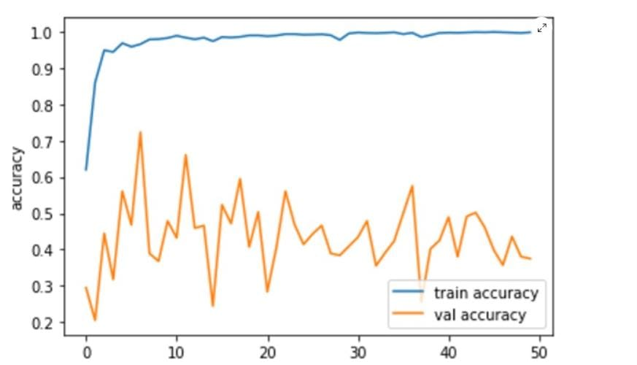
Fig .1.5 ACCURACY GRAPH

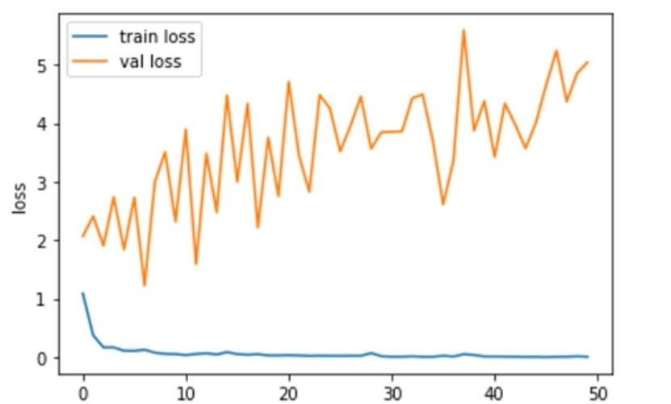
Fig.1.6 LOSS GRAPH

VI. CONCLUSION
A novel method for comprehending human emotions from speech is now accessible through Speech Emotion Recognition (SER), which employs Deep Learning’s systems can incorporate sophisticated techniques, such as Convolutional Neural Networks (CNNs), Recurrent Neual Network(RNNs) and transformers, to capture both the temporal patterns and spectral characteristics of speech. These models are more accurate and scalable than traditional machine learning methods.) Deep Learning-based SER systems are showing some promising results in areas such as customer service, mental health monitoring, and human-computer interaction. The problem at hand is not limited to noisy data, speaker variability, and cultural differences in emotional expression. However, they can be challenging.? Added features such as multilingual datasets, real-time processing capabilities and better generalization across different environments could be added in future.
VII.FUTURE ENHANCEMENT
The future enhancements to Speech Emotion Recognition (SER) will prioritize accuracy, adaptability, and real-world improvements.
1. Multimodal Integration:
Use of Speech combined with facial expressions, body gestures and physiological signals improves the accuracy in detecting emotions.
2.Real-time Processing:
Develop lightweight models designed for real-time emotion recognition in mobile devices or embedded systems.
3.Deep Learning Advancements:
Improve feature extraction and classification by utilizing advanced neural networks, such as transformers and graph neural network.
4.Cross-Language and Cross-Culture Adaptability:
Build resilient systems that are capable of identifying emotions across diverse cultural backgrounds and languages without any need for retraining.
5. Noise Robustness:
Build models to function correctly in environments with high levels of noise (e.g, during calls or public areas).”.
6. Multimodal Emotion Recognition:
Among the most promising directions are those that incorporate multiple data sources, such as: 1. Speech Signals utilize standard audio features, such as MFCCs, pitch patterns, and energy.
7.Real-Time Emotion Recognition:
In applications such as virtual assistants, call centres, and wearable devices, SER must operate in real-time: Targeting optimization is key to making deep learning models more computationally efficient for real-time inferences. Apply edge computing to smartphones or IoT gadgets, enabling quick emotion recognition using lightweight SER models. Real-time SER can enhance human-computer interaction by allowing systems to respond dynamically to user emotions. Use Case.
8.Explainable AI (XAI) for SER:
The "black box" mentality associated with deep learning models is often questioned. Key Features: Identify the features (pitch, tone, speech rate) that are most important in describing emotion. Healthcare systems can benefit from the use of personalized systems to track an individual's emotional state over time.
VIII.REFERENCE
[1]B.W.Schuller, “Speech emotion recognition: Two decades in a nutshell, benchmarks, and ongoing trends,” Communications of the ACM, vol. 61, no. 5, pp. 90–99, 2018.
[2]M.S.Hossain and G. Muhammad, “Emotion recognition using deep learning approach from audio–visual emotional big data,” Information Fusion, vol. 49, pp. 69–78, 2019.
[3]M. Chen, P. Zhou, and G. Fortino, “Emotion communication system,” IEEE Access, vol. 5, pp. 326–337, 2017.
[4]N. D. Lane and P. Georgiev, “Can deep learning revolutionize mobile sensing?” in Proceedings of the 16th International Workshop on Mobile Computing Systems and Applications. ACM, 2015, pp. 117–122.
[5]J. G. Razuri, D. Sundgren, R. Rahmani, A. Moran, I. Bonet, and A. Lars son, “Speech emotion recognition in emotional feedback for human-robot interaction,” International Journal of Advanced Research in Artificial Intelligence (IJARAI), vol. 4, no. 2, pp. 20–27, 2015.
[6]D. Leand E. M. Provost, “Emotion recognition from spontaneous speech using hidden markov models with deep belief networks,” in 2013 IEEE Workshop on Automatic Speech Recognition and Understanding. IEEE, 2013, pp. 216–221.
[7] A. B. Nassif, I. Shahin, I. Attili, M. Azzeh , and K. Shaalan, “Speech recognition using deep neural networks: A systematic review,” IEEE Access, vol. 7, pp. 19143–19165, 2019.
[8]J. G. Rázuri, D. Sundgren, R. Rahmani, A. Moran, I. Bonet, and A. Lars son, “Speech emotion recognition in emotional feedback for human-robot interaction,” International Journal of Advanced Research in Artificial Intelligence (IJARAI), vol. 4, no. 2, pp. 20–27, 2015.
[9]S. Lalitha, A. Madhavan, B. Bhushan, and S. Saketh, “Speech emotion recognition,” in Advances in Electronics, Computers and Communications (ICAECC), 2014 International Conference on. IEEE, 2014, pp. 1–4.
[10]K. R. Scherer, “What are emotions? and how can they be measured?” Social science information, vol. 44, no. 4, pp. 695–729, 2005.
[11]T. Balomenos , A. Raouzaiou, S. Ioannou, A. Drosopoulos, K. Karpouzis, and S. Kollias, “Emotion analysis in man-machine interaction systems,” in International Workshop on Machine Learning for Multimodal Interac tion. Springer, 2004, pp. 318–328.
[12]H. Gunes and B. Schuller, Categorical and dimensional affect analysis in continuous input: Current trends and future directions, Image Vis. Comput., vol. 31, no. 2, pp. 120136, Feb. 2013, doi: 10.1016/j.imavis.2012.06.016.
[13]S. A. A. Qadri, T. S. Gunawan, M. F. Alghifari, H. Mansor, M. Kartiwi, and Z. Janin, A critical insight into multi-languages speech emotion databases, Bull. Elect. Eng. Inform., vol. 8, no. 4, pp. 13121323, Dec. 2019, doi: 10.11591/eei.v8i4.1645.
[14]M.Swain, A. Routray, and P. Kabisatpathy, Databases, features and clas si ers for speech emotion recognition: A review, Int. J. Speech Technol., vol. 21, no. 1, pp. 93120, Mar. 2018, doi: 10.1007/s10772-018-9491-z.
[15]H. Cao, R. Verma, and A. Nenkova, Speaker-sensitive emotion recog nition via ranking: Studies on acted and spontaneous speech, Com put. Speech Lang., vol. 29, no. 1, pp. 186202, Jan. 2015, doi: 10.1016/j.csl.2014.01.003.
[16]S.Basu,J.Chakraborty,A.Bag,andM.Aftabuddin, Areviewonemotion recognition using speech, in Proc. Int. Conf. Inventive Commun. Comput. Technol., 2017, pp. 109114, doi: 10.1109/ICICCT.2017.7975169.
[17]B.M.Nema and A. A. Abdul-Kareem, Preprocessing signal for speech emotion recognition, Al-Mustansiriyah J. Sci., vol. 28, no. 3, p. 157, Jul. 2018, doi: 10.23851/mjs.v28i3.48.
[18]F. Burkhardt, A. Paeschke, M. Rolfes, W. Sendlmeier, and B. Weiss, Adatabase of German emotional speech, in Proc. 9th Eur. Conf. Speech Commun. Technol., 2005, pp. 14.
[19]P. Jackson and S. Haq, Surrey audio-visual expressed emotion (savee) database, Univ. Surrey, Guildford, U.K., 2014. [Online]. Available: http://kahlan.eps.surrey.ac.uk/savee/
[20]F. Ringeval, A. Sonderegger, J. Sauer, and D. Lalanne, Introducing the RECOLA multimodal corpus of remote collaborative and affective inter actions, in Proc. 10th IEEE Int. Conf. Workshops Autom. Face Gesture Recognit., Apr. 2013, pp. 18, doi: 10.1109/FG.2013.6553805.
[21]G. McKeown, M. Valstar, R. Cowie, M. Pantic, and M. Schröder, The SEMAINE database: Annotated multimodal records of emotionally col ored conversations between a person and a limited agent, IEEE Trans. Affect. Comput., vol. 3, no. 1, pp. 517, Jan. 2012, doi: 10.1109/T AFFC.2011.20.
[22]O. Martin, I. Kotsia, B. Macq, and I. Pitas, The eNTERFACE05 audio visual emotion database, in Proc. 22nd Int. Conf. Data Eng. Workshops, Apr. 2006, p. 8, doi: 10.1109/ICDEW.2006.145.
[23]A. Batliner, B. Schuller, D. Seppi, S. Steidl, L. Devillers, L. Vidrascu, T. Vogt, V. Aharonson, and N. Amir, “The automatic recognition of emotions in speech,” in Emotion-Oriented Systems. Springer, 2011, pp. 71–99.
[24]E. Mower, M. J. Mataric, and S. Narayanan, “A framework for automatic human emotion classification using emotion profiles,” IEEE Transactions on Audio, Speech, and Language Processing, vol. 19, no. 5, pp. 1057 1070, 2011.
[25]J.Han,Z.Zhang,F.Ringeval, andB.Schuller, “Prediction-based learning for continuous emotion recognition in speech,” in Acoustics, Speech and Signal Processing (ICASSP), 2017 IEEE International Conference on. IEEE, 2017, pp. 5005–5009.

